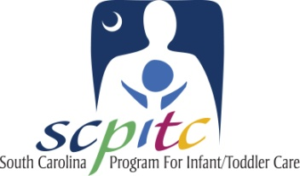

SC PITC Certified Infant & Toddler Guidelines (ITG) training will help you meet ABC Standards!

Training sessions on the Infant & Toddler Guidelines (ITG) are being offered across the state. Only ITG trainings that are certified by the South Carolina Program for Infant/Toddler Care (SC PITC) will count for credit in the ABC standards. To find SC PITC certified ITG training in your area, visit the ITG Online Training Database by following the instructions below or find a link at www.SCPITC.org. While you’re there you can register for the training of your choice or request that training be scheduled in your area!
Infant & Toddler Training Modules (2.5 hours each)

Module 1: Overview – Growth and Development
Module 2: Physical Health - Growth and Development
Module 3: Emotional Development – Growth & Development
Module 4: Social Development – Curriculum
Module 5: Motor Development – Growth & Curriculum
Module 6: Language Development – Curriculum
Module 7: Cognitive Development – Growth & Development

Log on and Registration Instructions
- Type http://www.ed.sc.edu/cdrc/itg/ into your browser.
- Click the “Click here to LOG IN" link.
- Click the “Don’t have an account?” link.
- Fill in your first name, last name, truncated Social Security number, and email address (if you do not have an email address, there are links to free email services) and click the "Create Account" button.
- Create a password for your account that has at least 6 characters and click the "Activate Account" button.
- Once you have created a password, fill in personal information page.
- Click the update button at the bottom of page. Your profile is now complete.
- Browse through the database to view available trainings and request trainings based on your schedule.

